Programs on Input statement

Aim: Programs on accepting input from user

# Write a python program to find the average of three numbers

## Source code:

num1 = float(input("Enter first number: "))

num2 = float(input("Enter second number: "))

num3 = float(input("Enter third number: "))

average = (num1 + num2 + num3) / 3

print("Average of numbers is", average)

## Output:

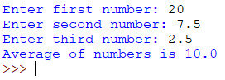

# Write a python program to convert the distance from kilometres to meters

## Source code:

kilometres = float(input("Enter distance in Kilometres: "))

meters = kilometres * 1000

print("Distance in meters is", meters)

## Output:



# Write a python program to convert time from hours to seconds

## Source code:

hours = int(input("Enter time in hours: "))

seconds = hours * 60 * 60

print("Time in seconds is", seconds)

## Output:



# Write a python program to accept length, breadth and height of a box and print its area and volume

## Source code:

length = float(input("Enter length of box :"))

breadth = float(input("Enter breadth of box :"))

height = float(input("Enter height of box :"))

area = 2 * ((length * breadth) + (breadth * height) + (height * length))

volume = length * breadth * height

print("Area is", area)

print("Volume is", volume)

## Output:

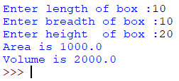

# Write a python program to find the distance of the vehicle travelled

## Source code:

speed = int(input("Enter speed of vehicle: "))

time = int(input("Enter time vehicle travelled: "))

distance = speed * time

print("Distance travelled by vehicle is", distance)

## Output:

## 

# Write a python program to carry out the operations

## Source code:

num1 = input("Enter first number: ")

num2 = input("Enter second number: ")

add = float(num1) + float(num2)

sub = float(num1) - float(num2)

mul = float(num1) * float(num2)

div = float(num1) / float(num2)

print("{0} + {1} = {2}".format(num1, num2, add))

print("{0} - {1} = {2}".format(num1, num2, sub))

print("{0} * {1} = {2}".format(num1, num2, mul))

print("{0} / {1} = {2}".format(num1, num2, div))

## Output:

## 